**Prashna Upaniṣad course with Ram Banerjee**

The later part of the Vēdās contain the knowledge section known as the Upaniṣhads. Prashna Upaniṣhad is one of the main 11 Upaniṣhads generally studied and comprises, as usual, of a conversation between student and teacher. In this case, 6 students each ask a series of questions grouped as six separate chapters. The questions are:

* How did life begin?
* What is a living being?
* What is the nature of a human being, and how is it so?
* What establishes human beings?
* What is meditation, and why meditate?
* What is that which is immortal?

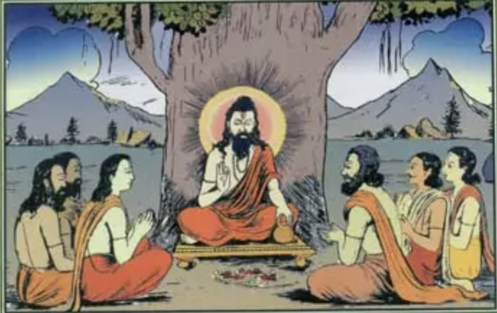This fascinating journey of discovery of the ancient teachings of the Vēdās will unfold weekly online over a series of 1.5hr classes starting Wednesday 22 May at 7.30pm. Every class will be recorded with the video, audio and class transcript being made available so that students may revisit the class to increase their understanding. The first block of 7 classes will cost £56 and registrations may be made at [www.arshakulafoundation.org/courses](http://www.arshakulafoundation.org/courses)

Ram Banerjee has been taking classes on the Upaniṣhads for over 10 years. He has a clear and often humorous mode of delivery which makes the subject easily accessible. This is the first time he has taught the Prashna Upaniṣhad which makes it a special journey of discovery for all. The course is open to existing students and those new to Vēdantā. Everyone is welcome so come and learn something totally new and exciting.